NETWORK PROTOCOLS AND COMMUNICATION (NPC) – UNIT 4
Configuring DHCP and Setting Up a LAN
Practical Assignment Report – Cisco Packet Tracer
Item | Details
Student Name | Aditya Devade
PRN | 2125UCSM1073
Subject / Module | Network Protocols and Communication (NPC)
Unit | Unit 4
Practical Title | DHCP Configuration and Network Setup
Tool Used | Cisco Packet Tracer
Project File | npc_unit4_DHCP.pkt

1. Aim
To build a small local area network (LAN) in Cisco Packet Tracer, assign a static IPv4 address to a server, enable and configure the DHCP service on that server, allow client PCs to obtain their IP configuration automatically, and verify connectivity between the clients using the ICMP ping command.

2. Theory in Brief
The Dynamic Host Configuration Protocol (DHCP) automatically provides hosts with the network parameters they need to communicate, such as an IPv4 address, subnet mask, default gateway and DNS server. It removes the need to configure each device by hand and helps avoid addressing mistakes and duplicate addresses. A DHCP server keeps one or more address pools and leases an address from a pool to each client that requests one. The server itself should use a fixed (static) address so that clients can always reach it.
Ping uses ICMP echo request and echo reply messages to test whether one host can reach another across the network.

3. Network Topology
The network contains one server (Server1, Server-PT), one Cisco 2960-24TT switch (Switch0) and two client computers (PC1 and PC2, both PC-PT). Server1, PC1 and PC2 are each connected to Switch0, forming a single star topology. All devices belong to the same IP subnet, 192.168.1.0/24. The link indicators in the Packet Tracer workspace are green, showing that all three connections are up.
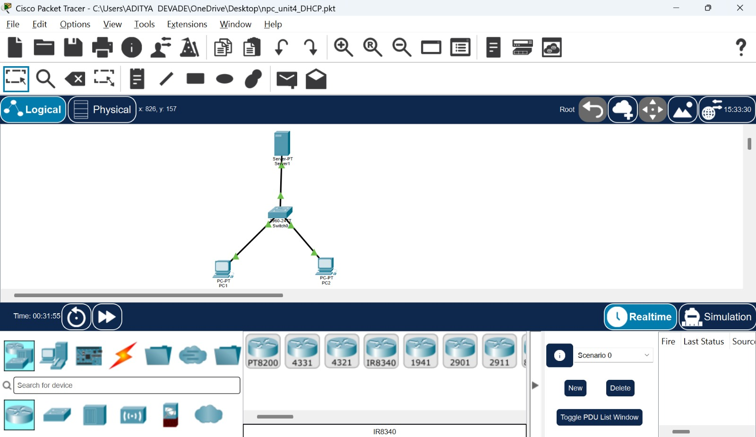
Figure 1: Network topology in Cisco Packet Tracer: Server1, Switch0, PC1 and PC2.

4. IP Addressing Plan
Server1 was configured with a static IPv4 address. The values below were taken from the Packet Tracer screenshots (Figures 2 to 5).
Device | Addressing | IPv4 Address | Subnet Mask
Server1 | Static | 192.168.1.2 | 255.255.255.0
PC1 | DHCP (automatic) | 192.168.1.10 | 255.255.255.0
PC2 | DHCP (automatic) | 192.168.1.11 | 255.255.255.0

5. Configuration Steps and Observations
5.1 Static IP configuration of Server1
On Server1, the IP Configuration window under the Desktop tab was opened and the Static option was selected. The configured values are listed below.
Parameter | Value (as shown in Figure 2)
IP configuration mode | Static
IPv4 address | 192.168.1.2
Subnet mask | 255.255.255.0
Default gateway | 0.0.0.0 (not set)
DNS server | 192.168.1.2
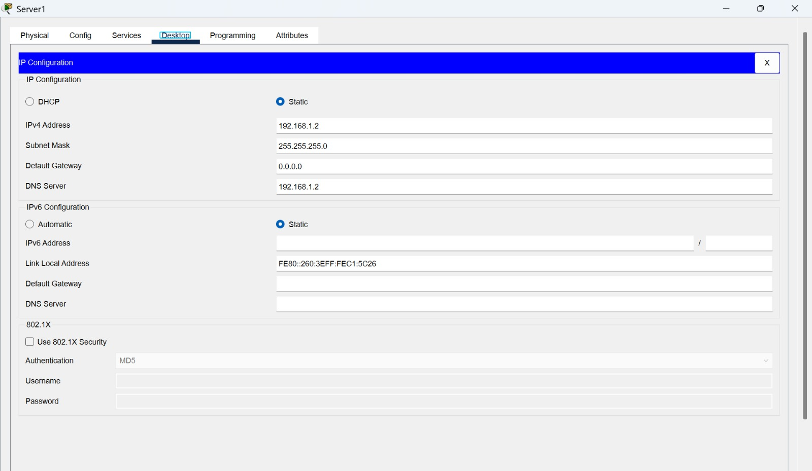
Figure 2: Server1 static IPv4 configuration (Desktop > IP Configuration).
5.2 DHCP service settings on Server1
Under the Services tab of Server1, the DHCP service was opened. The service was set to On for the FastEthernet0 interface and a pool named serverPool was defined and saved. The pool contents shown in Figure 3 are summarised below.
DHCP Parameter | Value (as shown in Figure 3)
Interface | FastEthernet0
Service status | On
Pool name | serverPool
Default gateway | 0.0.0.0
DNS server | 192.168.1.2
Start IP address | 192.168.1.10
Subnet mask | 255.255.255.0
Maximum number of users | 50
TFTP server | 0.0.0.0
WLC address | 0.0.0.0
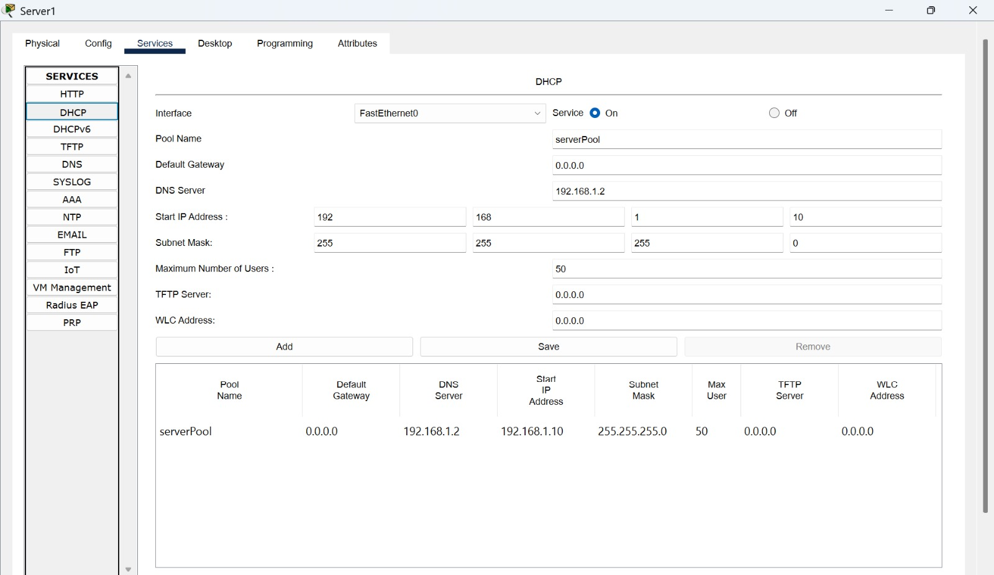
Figure 3: DHCP service settings and the serverPool entry on Server1 (Services > DHCP).
5.3 Automatic configuration of PC1 and PC2
On each PC, the IP Configuration window under the Desktop tab was opened and the DHCP option was selected. Both PCs received their IPv4 settings from Server1. PC1 obtained 192.168.1.10, which is the start address of the pool, and PC2 obtained the next address, 192.168.1.11. Both clients also received the subnet mask 255.255.255.0 and the DNS server address 192.168.1.2, matching the pool settings in Figure 3. The default gateway remained 0.0.0.0, consistent with the pool configuration.
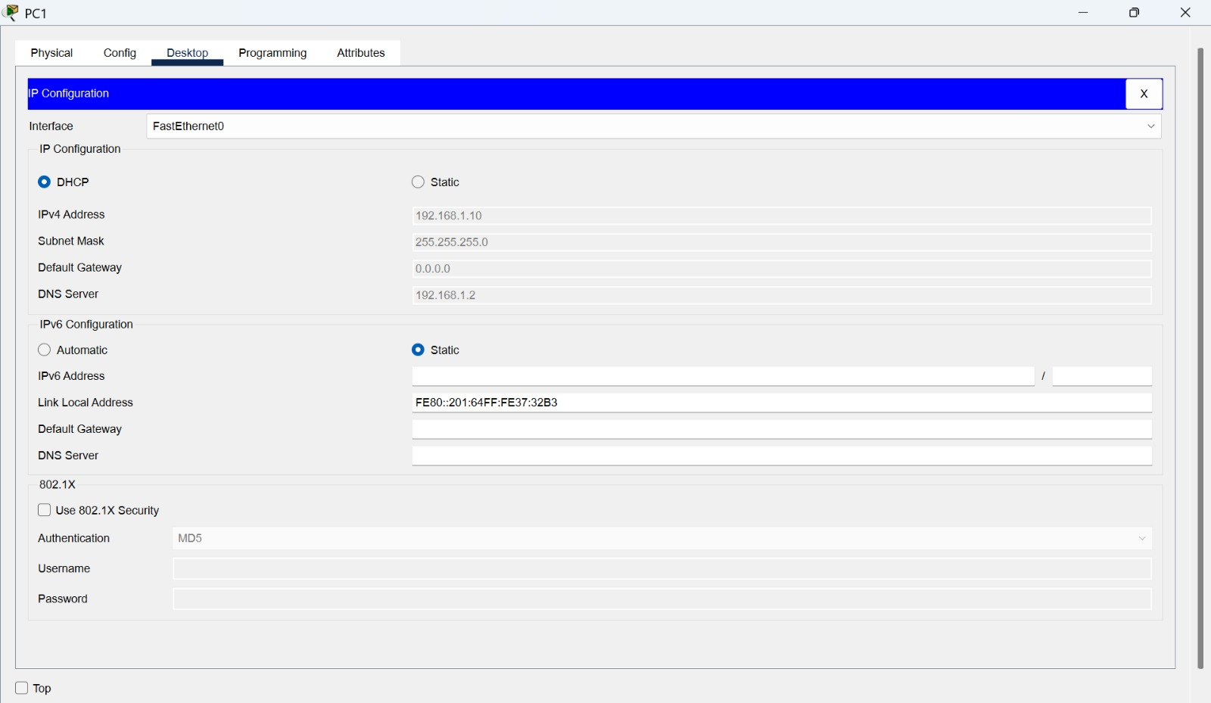
Figure 4: PC1 IP configuration using DHCP (IPv4 address 192.168.1.10).
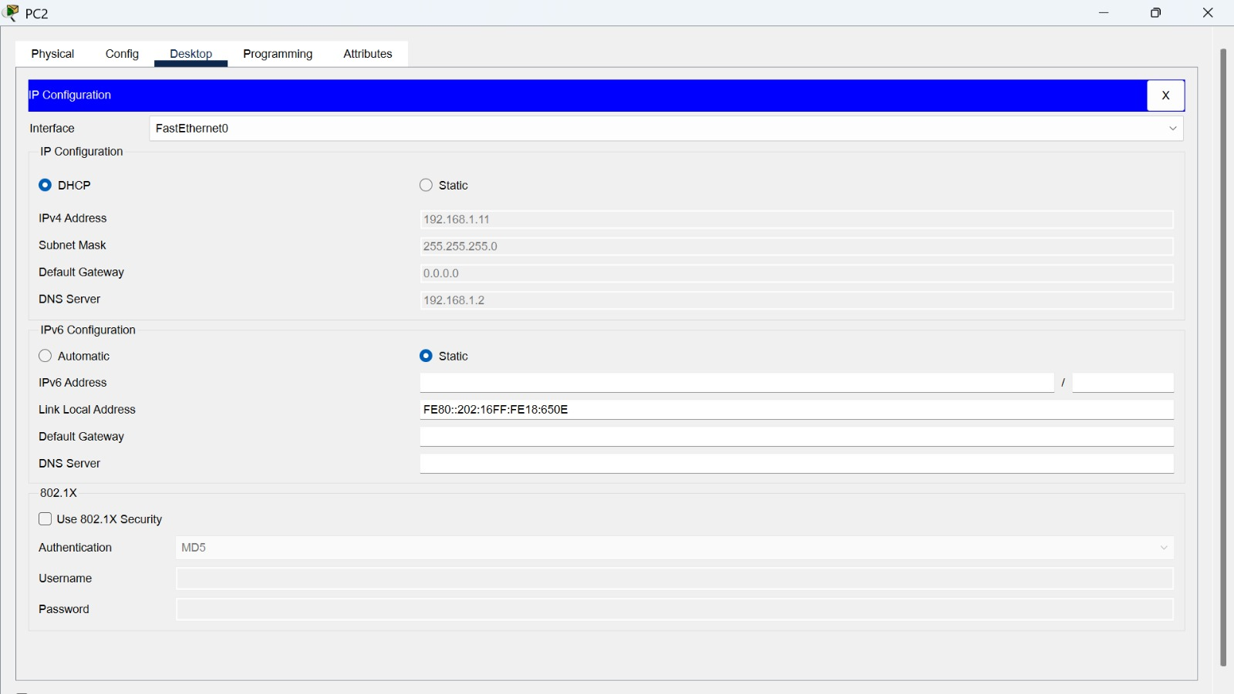
Figure 5: PC2 IP configuration using DHCP (IPv4 address 192.168.1.11).

6. Connectivity Testing
Connectivity between the two DHCP clients was tested with the ping command from the Command Prompt of each PC. The results are summarised below.
Source | Destination | Packets (Sent / Received / Lost) | Loss | Round-trip time (min / max / avg)
PC1 | 192.168.1.11 (PC2) | 4 / 4 / 0 | 0% | 0 ms / 0 ms / 0 ms
PC2 | 192.168.1.10 (PC1) | 4 / 4 / 0 | 0% | 0 ms / 7 ms / 1 ms

In Figure 6, PC1 pinged PC2 (192.168.1.11) and received four replies (32 bytes, time below 1 ms, TTL=128). In Figure 7, PC2 pinged PC1 (192.168.1.10) and also received four replies with TTL=128; one reply took 7 ms, which gives a maximum of 7 ms and an average of 1 ms. In both tests there was no packet loss.
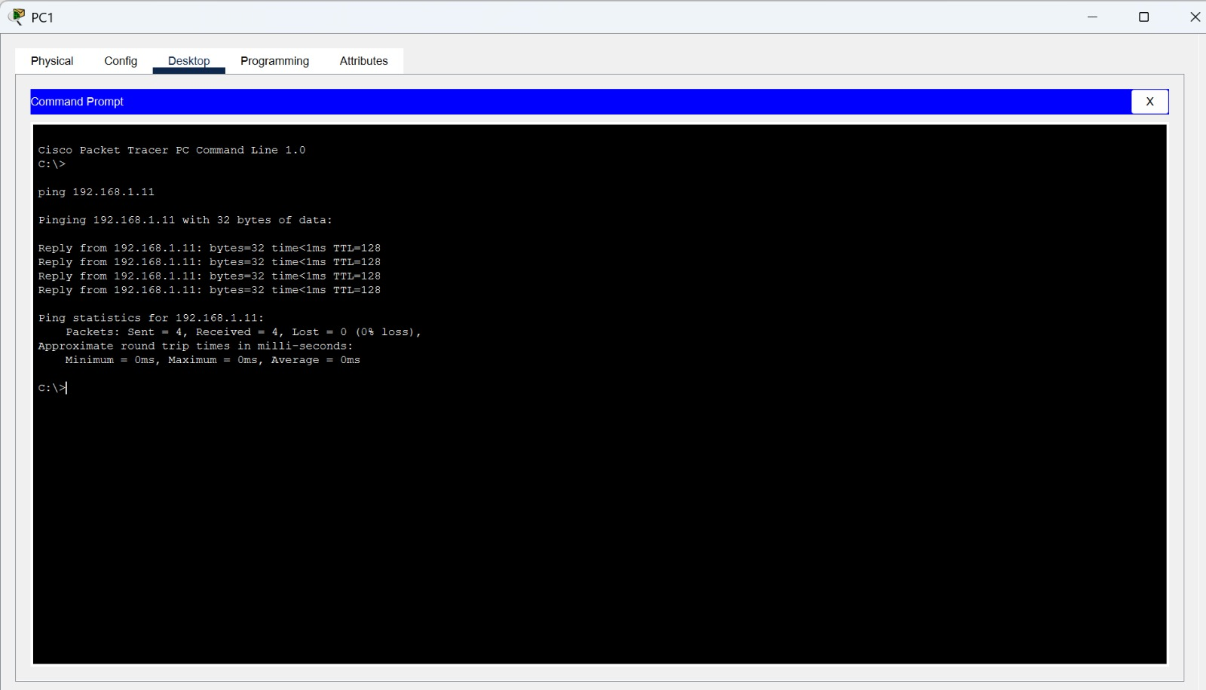
Figure 6: Ping test from PC1 to PC2 (192.168.1.11): 4 sent, 4 received, 0% loss.
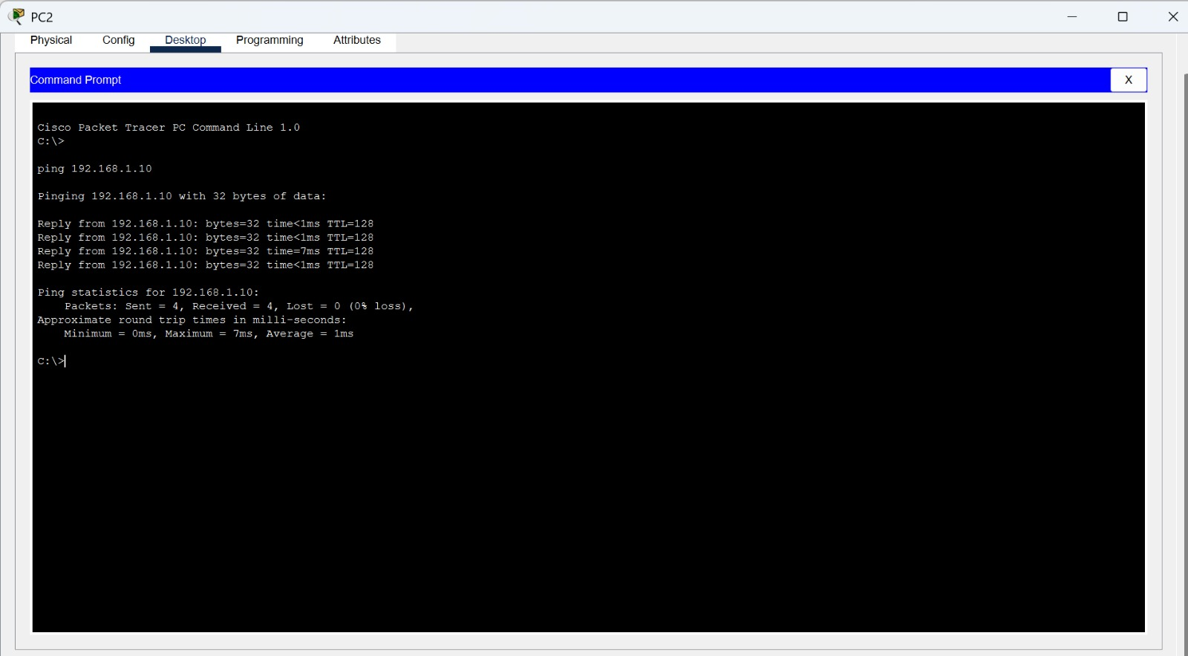
Figure 7: Ping test from PC2 to PC1 (192.168.1.10): 4 sent, 4 received, 0% loss.

7. Result and Analysis
- Server1 was assigned the static address 192.168.1.2/24, which lies outside the leased range that begins at 192.168.1.10, so the server’s own address is not handed out to a client.
- The DHCP service on Server1 was turned on, with the serverPool pool starting at 192.168.1.10 and allowing up to 50 users.
- PC1 and PC2 each obtained a unique address from the pool (192.168.1.10 and 192.168.1.11) without any manual entry, confirming that DHCP was working.
- Bidirectional pings between PC1 and PC2 succeeded with 0% packet loss, confirming Layer 3 connectivity within the 192.168.1.0/24 subnet.
- The default gateway is 0.0.0.0 because this practical uses a single subnet with no router; hosts in the same subnet communicate directly through the switch.

8. Conclusion
A small LAN consisting of one server, one switch and two PCs was successfully built in Cisco Packet Tracer. Server1 was given a static IPv4 address and configured as a DHCP server, and both client PCs automatically obtained valid IPv4 settings from it. Ping tests in both directions between PC1 and PC2 completed with no packet loss. The practical therefore demonstrates how DHCP simplifies address management in a local network.

9. Supporting Practical Evidence
The original Cisco Packet Tracer project file, npc_unit4_DHCP.pkt, is submitted together with this report as supporting evidence of the practical work. The project file contains the network that was built and configured for this assignment, and the screenshots in Figures 1 to 7 were captured from that project. The results reported here are documented from those screenshots, and the project file has been left unmodified.
Figure | Description | Source
Figure 1 | Network topology | Packet Tracer logical workspace
Figure 2 | Server1 static IP configuration | Server1 > Desktop > IP Configuration
Figure 3 | DHCP service and serverPool settings | Server1 > Services > DHCP
Figure 4 | PC1 DHCP configuration | PC1 > Desktop > IP Configuration
Figure 5 | PC2 DHCP configuration | PC2 > Desktop > IP Configuration
Figure 6 | Ping test from PC1 to PC2 | PC1 > Desktop > Command Prompt
Figure 7 | Ping test from PC2 to PC1 | PC2 > Desktop > Command Prompt

